|  |
| --- |
|  |
| October 4, 2019 – Binaakewe-Giizis(Falling leaves moon  Volume 8 Issue 3 |
|  |

Oshki Ogimaag 73 Upper Rd, PO Box 320



# Upcoming Events

October 11th

* NO SCHOOL *staff In service day

October 14th

* School pictures Preschoolers at 8:30

Order ON LINE at mylifetouch.com

ID: EVTWFS9DJ

* Indigenous People’s Day Fall Feast

(Community center gym -5pm)

October 16th

School Board meeting at 4:30

October 17th&18th

* NO SCHOOL*MEA

October 31st

Halloween Parade and Party starting at 1:00

## LUNCH MENU Oct 7-18, 2019

Monday – hot ham & cheese,tater tots,

v-8 juice, broccoli, pears

Tuesday – BLT’s, tomato soup, carrots, oranges

Wednesday –Baked chicken, mashed potatoes & gravy, carrots, oranges

Thursday – hot dogs, tater tots, beans, peaches

Friday – NO SCHOOL

Monday – bosco sticks, veggie sticks, mixed fruit

Tuesday – hard shell taco’s, corn, cornbread, mixed fruit

Wednesday – hamb gravy, mashed potatoes, carrots, pineapple

Thursday & Friday – NO SCHOOL

All meals come with bread & milk

OOCS menu can be found at oshkiogimaag.org

|  |
| --- |
|  |
|  |

[www.oshkiogimaag.org](http://www.oshkiogimaag.org) (218) 475-2112

Boozhoo, The weather is getting cooler- Please make sure your students come to school with coats and gloves to go outside for recess and for the Wabaan trips. We go outside everyday unless it is raining or real windy.

**Kindergarten News:**

Kindergarten has been busy helping with the harvest season! We went on a field trip to Eagle Marsh and met up with Trust Lands. We were able watch and learn how to harvest Maanoman. Students were able to practice ricing in a canoe on land and are looking forward to next year when we can go out on the water! Last Friday our school walked down to the National Monument and processed wild rice. We learned how to Parch the rice and help stir in a big kettle over the fire. Dance on the rice to help break down the husk and then practiced winnowing the wild rice using birch bark baskets. We were very curious this trip, thank you to everyone who made this possible! While the older kids harvested vegetables from the community garden our class picked apples. We picked two different kinds; green apples for baking and crab apples for making jelly. Ms. Bonita and the first and second graders came into our class to teach us how to make jelly. With their help we washed, cut up, and measured the apples, sugar and water so they were ready to cook. Ms. Bonita strained the juice through mesh and finished the process by canning it, she saved us some and we were able to try it on crackers for snack! We look forward to baking apple treats for the Oshki’s Fall Harvest Feast, we just started making decorations, please join us on October 14th! Many students in our class met September’s reading goal and were able to pick prizes, Great work! We are starting our October challenge is 400 reading minutes, please help our class meet our goal!

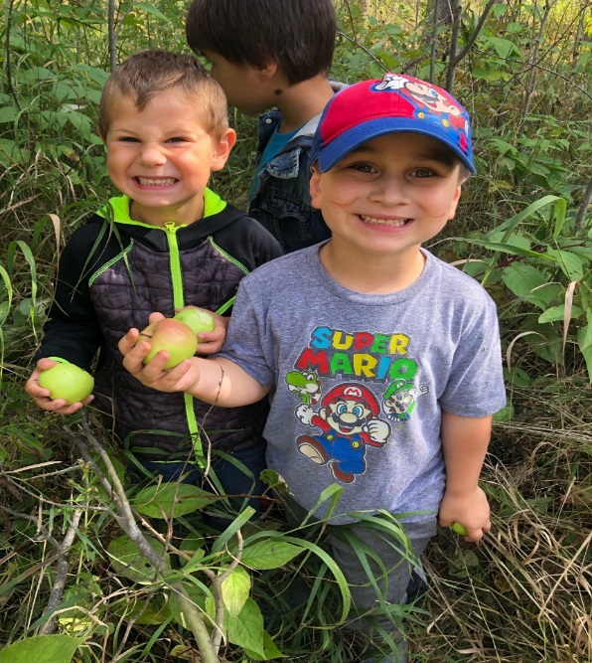

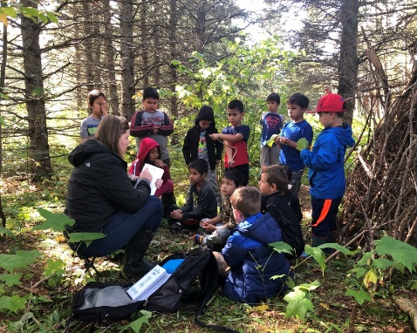

First and Second Grade News:

In the morning Ms. Clearwater has been our substitute teacher. We have been decoding words for reading and spelling that have the ee,ea,oa and ai. We learned that a homonym is two words that sound alike but are spelled differently..like tale and tail.

On September 21st it was Batman’s 80th birthday, we have been learning facts about bats and using those facts to create sentences using our reading words! It will be Paxton’s birthday in October!

Taedyn: Bats float in the air.

Bii: Bats squeak for echolocation.

Cassidy: Mosquitoes flee from bats!

Trace: The bats flew and saw a trail.

Ira: Bats like to eat mangoes.

Paxton: The bat hung in the oak tree.

We then made bats for art that can fly in our classroom! We read the book “Stellaluna” that is about a fruit bat. We all got to taste a mango..the first graders didn’t like it but the second graders loved the flavor.

In math we are learning about money and how to count it. Pennies, nickels, dimes and quarters also have a history…we learned that the first penny was as big as a half dollar! We have talked about the people and items on the front and back of our coins. Do you know what is on the back of a dime and what it stands for? Ask a first or second grader! Using clocks to tell time, counting by two, five and ten…adding and subtracting, using the more than, less than signs and using our number grids are our other exciting math activities we have accomplished during the past two weeks.

The second graders are reading the book “Why the Sky Is Far Away” and the first graders are reading “School Star”. In our quiet reading time our most favorite books are about Pete the Cat!

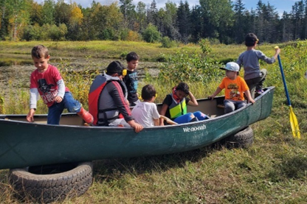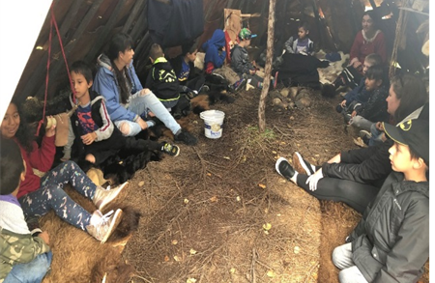

October 2019 – Bonita Poitra/ Cultural Liaison

Boozhoo Families! We are busy harvesting our gardens and preparing for our annual Indigenous Peoples Day Feast. We have formed a committee of our students and have picked recipes and have started making a menu. K-2 grade made Crabapple Jelly and we are able to share a small jar with their family. 4-6 graders are making pickles this week and also making pickled banana peppers. We have pulled the dehydrators out and are planning on what we will preserve for later use. We have plenty of produce to make our dishes and are excited to be able to prepare a feast for the community.

We love to offer foods that we harvest from Grand Portage, but would also like to include wild game, so we are currently seeking donations of fish, venison, grouse and moose.

Culture this month is all about a feast and how we include traditional foods in a feast. Mr. Erik is teaching our older students how to say a prayer in Ojibwemowen.

Our Parent Advisory Committee is helping to set up and clean up the Community Center before and after the feast. If you would like to help, it would truly be appreciated! If parents would like to donate a dish or their time, we will accept any and all the help we could get! Miigwech!