November 4, 2019 / Gashkadino-Giizis – freezing over moon

Volume 8 Issue 5
Oshki Ogimaag 73 Upper Rd, PO Box 320

Upcoming Events
Nov 6- Fieldtrip to GM
Nov 7- Parent/Teacher Conferences, Book Fair, Parent Committee Meeting
Nov 23- Craft Fair at OOCS still looking for vendors. Shoppers could come and support us between 9:30-1:30 that day.
Nov 27-29-NO SCHOOL Thanksgiving Break
Lunch Menu – Nov 4th – 15th, 2019
Monday- chicken burger, seasoned rice,
Tuesday- taco’s, refried beans, cornbread
Wednesday- bag lunch
Thursday- hotdogs, oven fries
Friday- shrimp poppers, mac&cheese

Monday- bbq beef rib sandwich, oven fries
Tuesday- buffet day/ nuggets, pizza, hotdogs, tater tots
Wednesday- hamb gravy & mashed potatoes
Thursday- chicken quesadilla
Friday- soup, sandwiches

All meals come with a vegetable, fruit, bread & milk
OOCS menu can be found at oshkiogimaag.org

www.oshkiogimaag.org (218) 475-2112

Happy November everyone. The First quarter of school is already behind us, Parent/Teacher Conferences will be Thursday from 3:30-5:30. If you are unable to attend in that time frame please contact your students’ teacher to set up an appointment to meet with them. You can do this by calling before 8:30 or after 3:15 or by sending a note with your child. Thursday is also the Scholastic Book Fair and the Parent Committee meeting.
Wednesday of this week we will not be going to Wabaan. We will be going to the presentation of Woodland Sky by The Native Dance Company at ISD 166. We will also be going to the library so students could bring their library card if they have one. Lunch that day will be a bag lunch made by Jeanne.

JOB OPENING: We are looking for a part time paraprofessional. This position would be mornings with the occasional full day. Pay is dependent on experience. Willing to train the right person. Needs to be dependable, patient with kids, pass background check and drug test.
Thank you to Federal Credit Union and GP Human Services for your donation for the Book fair. This helps ensure every student gets a book! And helps OOCS get new books and resources.
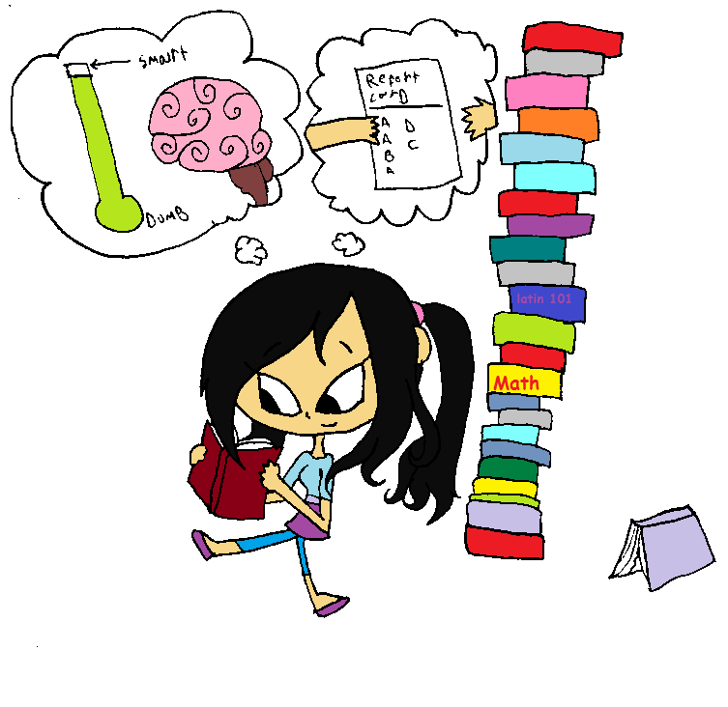
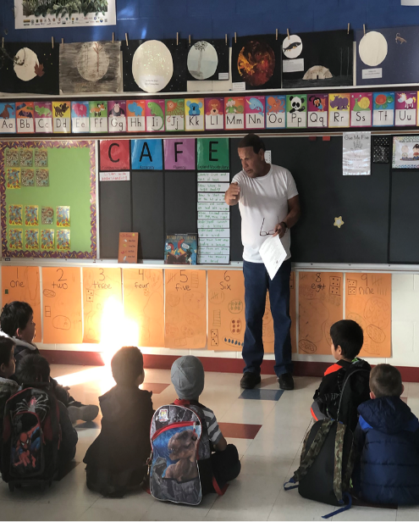
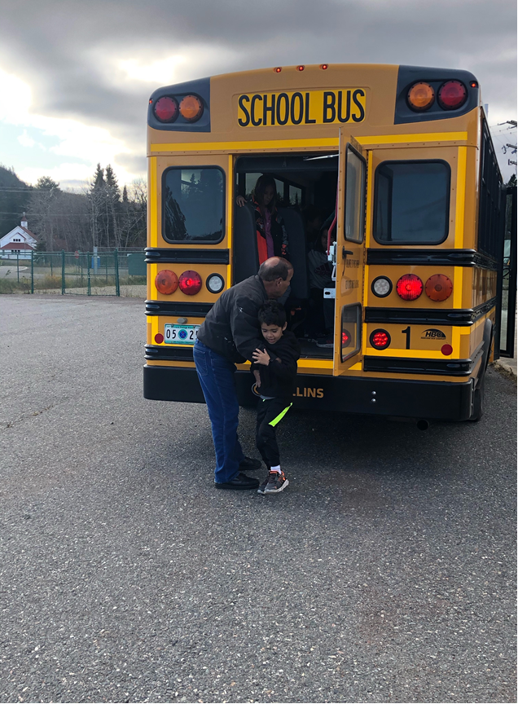
Kindergarten has been busy getting ready for Halloween! We have had lots of spooky art projects, decorating our hallways. All of us enjoyed the Halloween Carnival at the Center last week, we would like to say thank you to all the community volunteers who pulled together to make this possible! Our bus driver Mr. Fish came into our classroom to teach us how to be safe on the bus. We practiced the evacuation drill off the back of the bus, so we are prepared in case of an emergency. Students had lots of fun playing tennis again with our tennis teacher Charlie, we are grateful for the opportunity to learn a new sport! Our class is learning to read and spell new words, please help your child practice our current red words; The, is, A and I. Most of our students went over their individual reading goals! Keep up the great work!

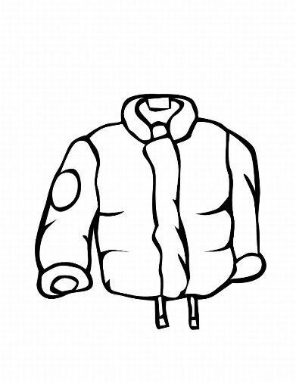
Congratulations to those students that had Perfect and Almost Perfect Attendance in the 1st Quarter of the School Year! There were 5 that missed 0 days, 4 that missed only 1 day. They all were able to pick from the Prize box. I hope to have even more students with Perfect Attendance in the 2nd Quarter!
Student Attendance at School is very important and parents should always make sure their child gets to school on time if they are not ill. Wabaan days are no exception- if your child should not be at Wabaan due to not having warm clothes let us know and we will help find some.

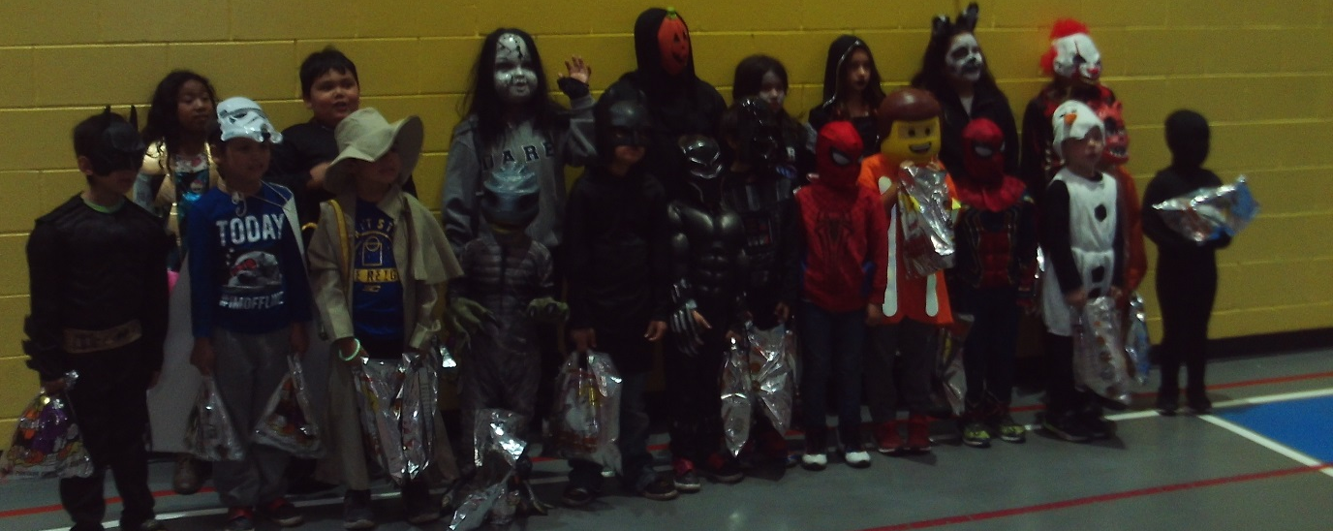
It is COLD out- students need warm clothes. Human Services is having a Coat Drive. Contact them if anyone in your family needs a coat or other warm gear.

