|  |
| --- |
|  |
| November 15, 2019 / Gashkadino-Giizis – freezing over moon  Volume 8 Issue 6 |
|  |

Oshki Ogimaag 73 Upper Rd, PO Box 320



# Upcoming Events

November 20 School board meeting @ 4:30pm.

November 23 Craft Fair, Bake Sale and Chili Feed at OOCS 9:30-1:30.

THANKSGIVING VACATION: Wednesday, November 27th- Friday, 29th.

Lunch Menu – Nov 18th – 26th, 2019

Monday – mini corndogs, oven fries, green beans, peaches

Tuesday – lasagna, coleslaw, garlic toast, pineapple

Wednesday – chicken gravy & mashed potatoes, carrots & peas, peaches

Thursday – hamburgers, tater tots, corn mixed fruit

Friday – pizza, salad, v-8 juice, pineapple

Monday – chili, grilled cheese, carrots * celery, oranges, crackers

Tuesday – “Lucky Tray Day ”French toast, sausage, applesauce, juice

All meals come with bread & milk

OOCS menu can be found at oshkiogimaag.org

|  |
| --- |
|  |
|  |

[www.oshkiogimaag.org](http://www.oshkiogimaag.org) (218) 475-2112

Boozhoo, The cold weather is definitely upon us and even a blanket of snow. Make sure your student comes to school with boots, coat, snow pants and hat & mittens. We go outside every day and will be going to Wabaan on Wednesday. Warm kids are happy kids!

OOCS Annual meeting of the School Board will be December 11 –Supper at 5:30, Meeting and Voting for School Board Member at 6:00. There will be crafts for the kids during the meeting supervised by staff members. Hope to see you all there. Parents, Guardians and School Staff are all voting members.

Mark your calendar for the Annual Holiday Program December 19- more information will be sent out after Thanksgiving.

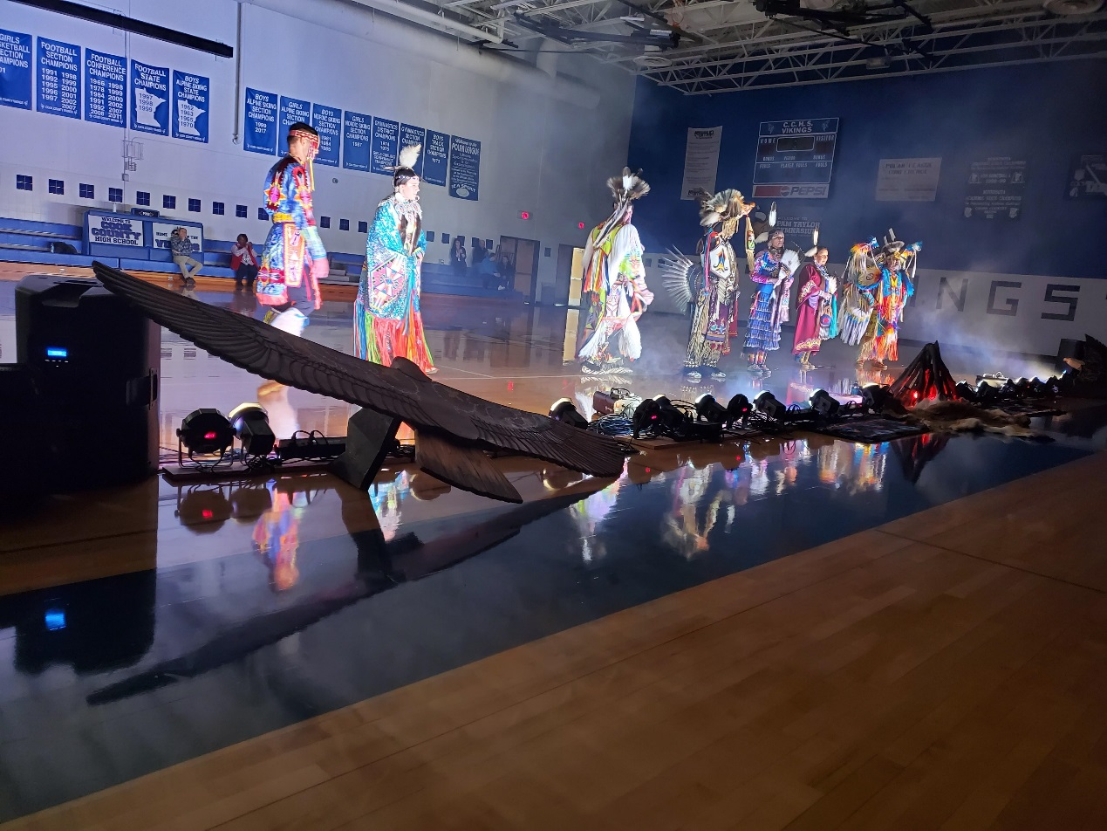Hope you can join us a the Craft Fair- many local crafters will have items for sale as well as the Parent Committee will be serving chili for lunch. Come and support the Parent Committee.

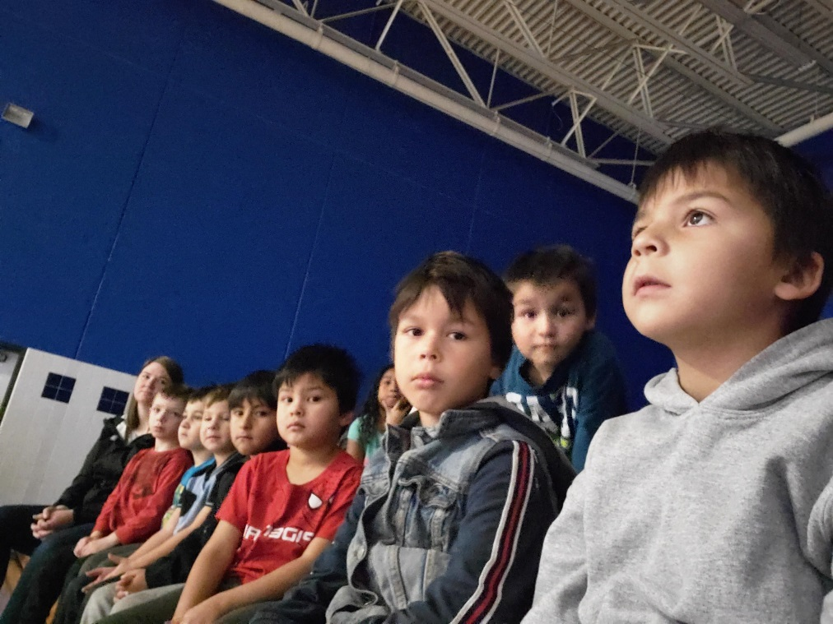Kindergarten, First and Second graders have been super busy these past two weeks! We have had two field trips to Grand Marais. The first was to watch the Woodland Sky Native American Dance Company perform at Cook County High School. Our students liked listening to the stories being told along with watching all the different styles of dance. We ate lunch in the cafeteria there and were amazed at all the different age groups of children coming and going during their lunch hours. After lunch and recess we went to the library and had story time and songs with Ms. Erica. We also checked out books for our classroom. Our second trip to town we were invited by the ACA to watch the performance of the musical The Little Mermaid. All the Oshki students really enjoyed this! We were even complemented by the staff there for being a good behavior, Good Job! For recess both days all the Oshki students LOVED playing on the community center playground and skate park. We have a lot of fun, even the adults! Tuesdays are continuing to be Tennis with Charlie in the gym. We have been learning and playing floor hockey and all the kids have been awesome! In science we are continuing our habitat unit, this time learning about Ponds. Ask your child about what their vocabulary words are, they are amazing at remembering their new words as well as past vocab words from previous habitats!

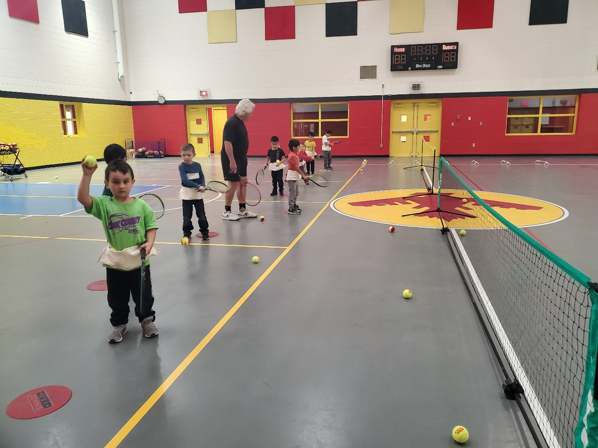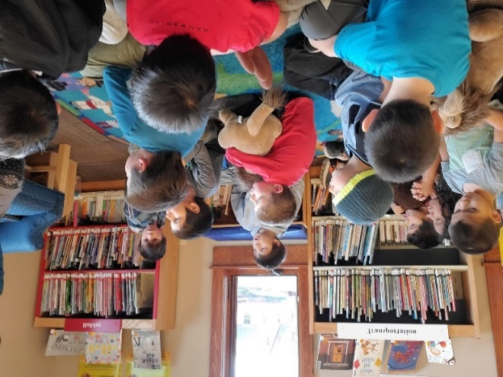

The weather is changing and all grades are wrapping up the weather unit.  We learned 13 weather verbs such as gisinaa (it’s cold)

noodin (it’s windy)

zoogipon (it’s cold).

Grades 4-6 also worked on the past tense.  Here are a few examples:

Gii-awan zhebaa.   It was foggy this morning.

Gii-animikiikaa dibikong.  It thundered last night.

Gii-ningaanakwad bijiinaago.  It was cloudy yesterday.

Ojibwemowin Director- Erik Redix

Don’t forget the Ojibwe Language Table every Monday 5:30-7:00 P.M. in the Oshki Conference Room.  We had a good turn out for the first session.  You can join anytime and learn some of the Ojibwe our students are learning.  Light refreshments provided and everyone is welcome!

Culture- Bonita Poitra

Working with K-2 on dyeing fabric with plant based dyes. We used two methods of dyeing, dipping method and tie dye. Each student made two dyed pieces of material and then we dried and ironed the material. We also are working on sewing small aromatherapy sleep pillows using harvested herbs from our garden and flowers. We will be selling these little pillows at our Craft Fair.

Working with 4-6 on a lesson about Food Cashe Pits of the Ojibwe. We talked about the use of refrigerators, freezers, dehydrators that we use now, and what the Ojibwe people used. We also decided to dig a cashe pit, and bury food for our Sugarbush camp. We buried lots of goodies to dig up later this spring and created a map to get us to the right spot to dig!

4-6 will be working on bagging up the teas that we grew this year for our Craft Fair.

**4-6 Grade** Mr. Brooks/Ms. Kat

In the 4-6 classroom, the students ended our first quarter with a bang! Halloween was a big event for our entire school. We hosted our annual Halloween parade, which allows family and members of the community to come in and watch their kids participate in receiving candy and showing off their Halloween costumes. After the parade, students from other classes got a chance to come into our classroom and take a trip through our Haunted House! The students in 4-6 worked very hard on this, and it showed!!

In the classroom, the students have been learning how to read topographic maps. A topographic map is a representation of a three-dimensional surface on a flat piece of paper. Topographic maps have a variety of uses, from planning the best route for a hike to determining a location for a school or an airport.

The entire school got a chance to go on our first field trip to Grand Marais, and the day was filled with fun! First we went to Cook County High School to watch the Native American Dance Company Performance, Woodland Sky! Woodland Sky is made up of award-winning singers and dancers who span multiple generations. After the performance, we had lunch at Cook County High School, then proceeded to enjoy recess at the playground located by the Cook County Community Center. From there we went to the library where the kids got a chance to start making their own comic strip! It was an awesome day!

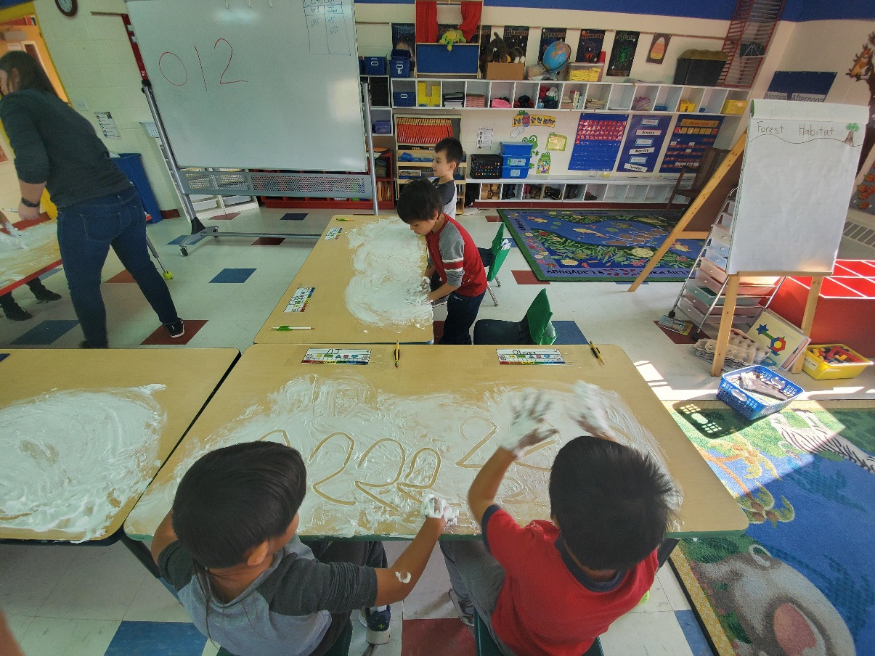This past week, the school got to go on our second field trip of the year! This time we went to the Cook County Playhouse to watch a very enjoyable production of the Little Mermaid! The students really enjoyed it!