January 24, 2020 – Gichi Manidoo Giizis / Great spirit moon

Volume 8 Issue 9
Oshki Ogimaag 73 Upper Rd, PO Box 320

Upcoming Events
Feb 14 & 17 NO school for students
Feb 19 School board meeting
Lunch Menu – Jan 27-31, 2020
Monday – Sloppy joes, tater tots
Tuesday – French toast, sausage
Wednesday –Tater tot hotdish
Thursday – Salmon bites, mac & cheese
Friday –Indian taco’s

All meals come with vegetable, fruit, bread & milk
OOCS menu can be found at oshkiogimaag.org

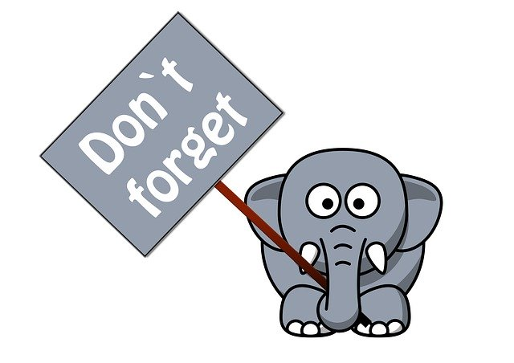
Don’t forget the Ojibwe Language Table every Monday 5:30-7:00 P.M. in the Oshki Conference Room. You can join anytime and learn some of the Ojibwe our students are learning. Light refreshments provided and everyone is welcome!

www.oshkiogimaag.org (218) 475-2112

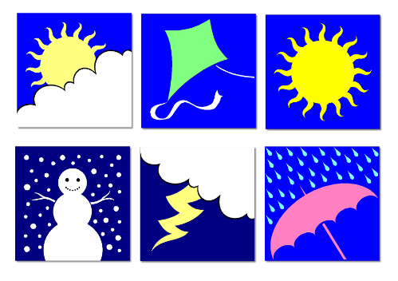
Weather Closures: In the event we need to close due to inclement weather or other unforeseen reasons, you will receive a call from our school automated phone service. It will also be posted on Facebook and TV channels 6 and 10. This is one of the many reasons why you need to make sure that we have your current phone number on file here at OOCS.

Absences: If your child will not be at school, YOU need to notify the school. If we do not hear from you, your student will be marked UNEXCUSED.
Illness: In the event that your child is ill and has a fever, is vomiting or has diarrhea- please keep him or her home until they have been fever free or vomit and diarrhea free for 24 hours. Don’t forgot to call the school- leaving a message works great if we are unable to answer.
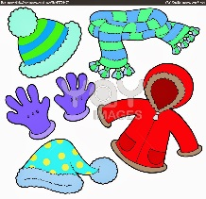
Warm clothing: Your child should have appropriate winter gear every day! This includes snow pants, boots, hat and mittens!

February 24: The ABCs of the IEP: Making the IEP Work For Your Child FREE This workshop is offered by Cook Co Higher Ed-you should contact them with questions and to sign up.
Hosted and Presented by the Pacer Center
This workshop will help parents understand how to use the Individualized Education Program (IEP) to benefit their child. Participants will use a PACER booklet to understand how each required part of the IEP can be developed to meet the child’s needs. Parents will gain knowledge about how to participate effectively in the annual IEP meeting.
OJIBWE LANGUAGE
Since the holiday break, Kindergarten is working on their animals. Grades 1-2 is working on describing what we are doing. For example, “wiisini” (he is eating) and “niwiisin” (I am eating). Grades 4-6 worked on describing events in the past. For example:
Person 1: Aaniin gaa-izhichigeyan bijiinaago? What did you do yesterday?
Person 2: Ningii-koshkoz akawe. Mii-gaa-zhi- First I woke up. Then I played.
odaminoyaan.
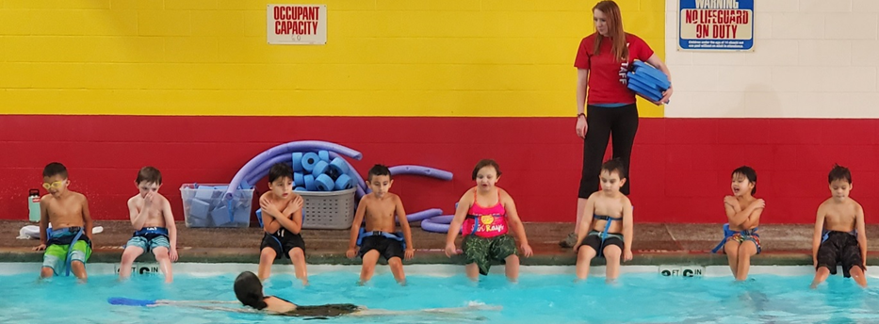

Kindergarten NEWS:
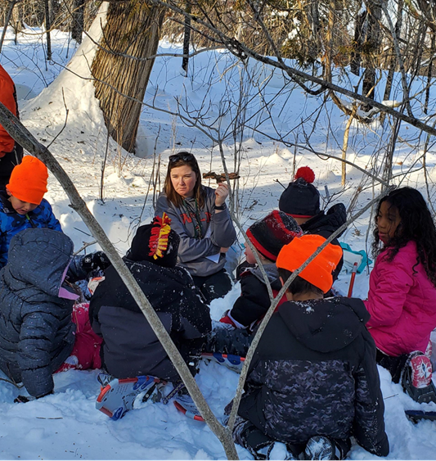
Kindergarten has been super busy keeping up with our schedule. Everyone is loving swimming lessons on Monday, Thursday and Friday afternoons. The students are improving their skills in both tennis and archery. Archery has become a school wide favorite and everyone looks forward to Thursdays. Wednesdays have been fun with all the snow we have gotten. Our class has been borrowing snowshoes from Grand Portage State Park, to explore areas surrounding Waaban. Testing is wrapping up and we’re very happy with the kindergarteners’ progress and improvement! Our class has gone through the entire alphabet, learning each letter name and each letter sound. The students are getting good at putting three letters together and blending the sounds to read a word. We have started a new science unit learning all about the polar habitat. Tess joined our class to teach us about germs and the right way to wash our hands, ask your child to show you the right way to wash hands. Second quarter has ended, and we are ready to begin third quarter.
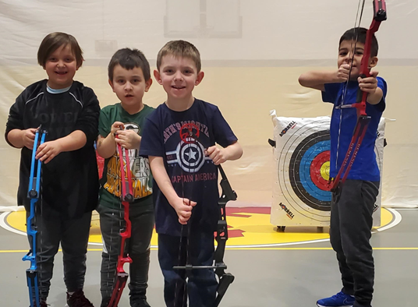
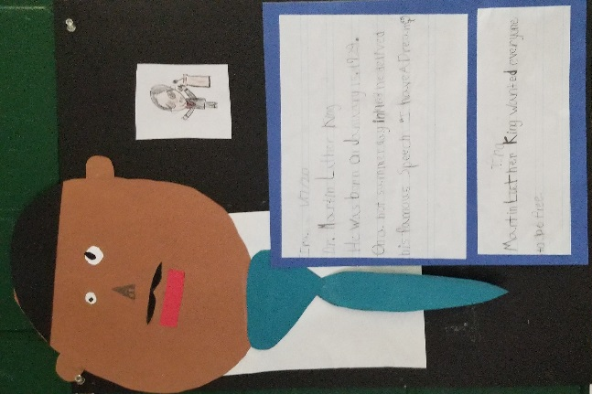
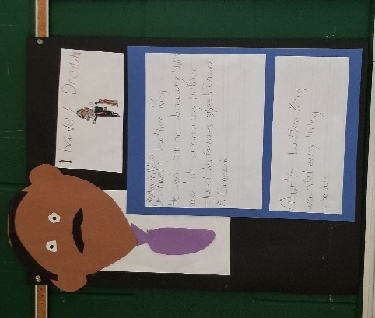

Grades 1 and 2
Mrs. Clearwater has been incorporating writing into history, science, poetry and trivia. This week they used writing with art and history as the students learned about Martin Luther King. The 1st and 2nd graders have really been enjoying swimming and archery. They are learning how to do some multiplication and about place value! The students love reading out loud with different adults in our building-reading out loud and with adults is a great way to practice their reading skills.

4-6 Grade Mr. Brooks/Miss Kat
In History, the students have been learning about the Industrial Revolution, which changed every aspect of everyday life, from how we wash our clothes to how we work, how we communicate, and how we travel. They learned about how other inventions have also impacted our lives, such as the steam engine and the telegraph.
Each class in the school gets the opportunity to participate in Reading Buddies. This is when the kids from Head Start come into our class and our students get the opportunity to read to them. Our students have been doing a great job and the kids from Head Start really enjoy the time they get to spend with them.
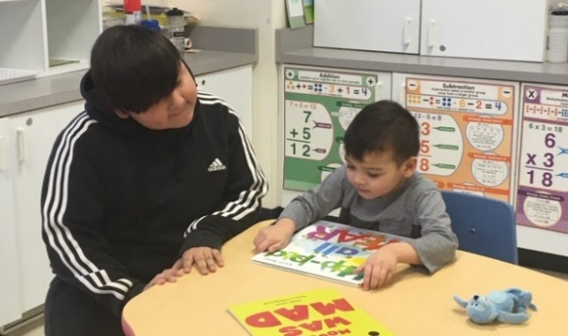
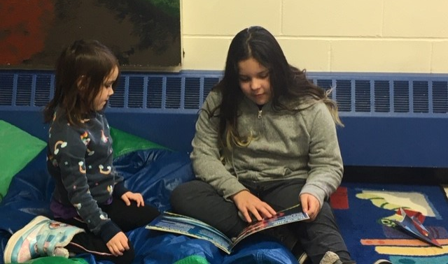
At Waaban, the students have had the chance to explore the woods and observe many changes in the environment each time we go. The last couple weeks we have been practicing routines that help us observe, ask questions, and draw conclusions about things that we see. We also have been working on our Phenology board again this year, which allows the class to record changes in nature that we see each week. There is also quite a bit of snow at Waaban, so we have been using the snowshoes and making trails, and preparing for Sugarbush.
Archery has started! All the kids really enjoy it and are developing some great skills. They have been learning range safety and proper shooting techniques, this encourages focus, increase self-confidence, and team building skills. Miigwech to Anna and Daniel from the Grand Portage State Park who have made this all possible
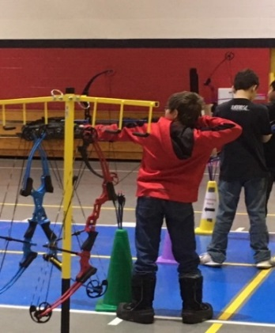
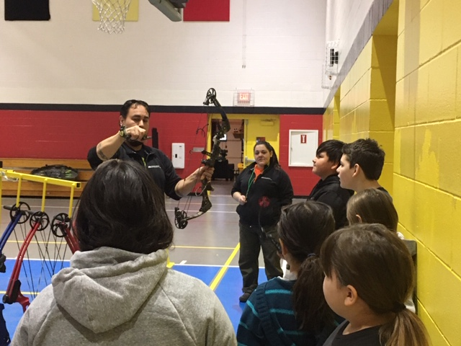

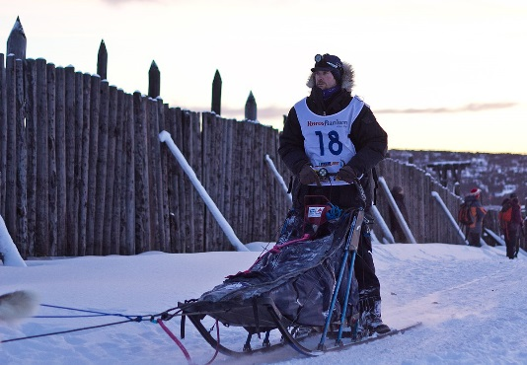
It is Beargrease week! The race is starting Sunday in Duluth and finishing Tuesday in Grand Portage! If you are interested in watching the finish as a family event you can check out beargrease.com for updates as to when the teams will come into Grand Portage. John Beargrease was a Grand Portage Band Member, it is very exciting that the race ends here- learn about the Beargrease history in the Fearless John book by Kelly Emerling Rauzi or the John Beargrease by Daniel Lancaster

