|  |
| --- |
|  |
| February 21st, 2020 – Namebini-Giizis(sucker moon)  Volume 8 Issue 10 |
|  |

Oshki Ogimaag 73 Upper Rd, PO Box 320



# Upcoming Events

March School Board Mtg- March 11 @ 4:30

In service and Spring Break March 20-27 NO School

Lunch Menu – February -24 – 28, 2020

Monday – hotdogs, tater tots

Tuesday – shrimp poppers, mac & cheese

Wednesday – lasagna, salad, garlic toast

Thursday – French toast, sausage, applesauce, juice

Friday – Indian taco’s, fruit salad

All meals come with vegetable, fruit, bread & milk

OOCS menu can also be found at oshkiogimaag.org

|  |
| --- |
|  |
|  |

[www.oshkiogimaag.org](http://www.oshkiogimaag.org) (218) 475-2112

The 2nd Annual Aadizookaan: Traditional Ojibwe Storytelling was held on Tuesday night and was very well attended!

Lac La Croix elder and teacher Maajiigwaneyaash (Dr. Gordon Jourdain) also did an afternoon program at the school for students.

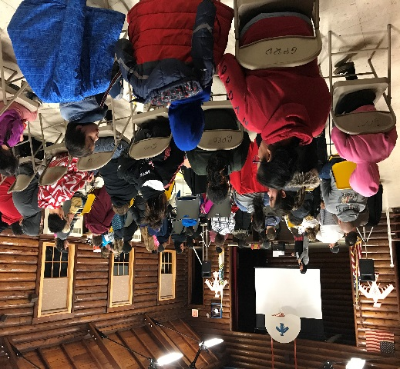 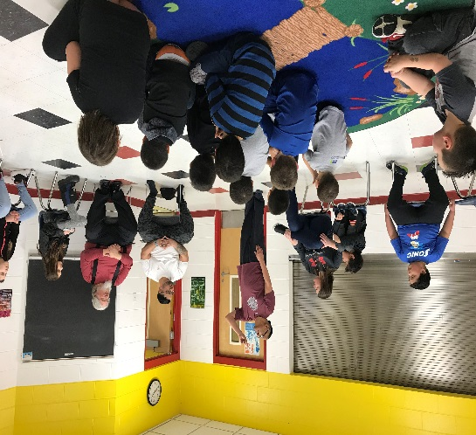

Our students snared rabbits to provide food for the CACHE program’s Food 4 Thought.  Grades 4-6 set snares two weeks ago and checked them daily.  This is important to teach our students that when the animals chose to give their life to us, we have to make sure and use them responsibly, and not waste.  So far, we've got two rabbits!

Bonita Poitra / Cultural Liaison

This week we are still working on Storytelling with our 1-2nd grade class on comparing two stories with similar themes. The first is Nanaboozhoo Steals Fire and also reading the Salish Coyote Story of Beaver Steals Fire. We will read both books and compare and contrast the two stories.

Planning for our Sugarbush Camp with our older students and finding activities and lessons that we can do at our camp, we will be including science, math and language arts along with culture and language, and the tapping of trees! One new thing we would like to try is getting our syrup to the granulated sugar stage, but to do this we will need a wooden trough that has been hollowed and smoothed and a paddle. If anyone knows of someone who can make us one or let us use, could you send them our way?

Absences: Please remember: If your child will not be at school, YOU need to notify the school. If we do not hear from you, your student will be marked UNEXCUSED. Thank you

Kindergarten NEWS:

We finally reached 100 days of school! The students were excited to celebrate that milestone. On the 100th day the students made crowns with the number 100 on them, they were working on writing 100 words through- out the whole day. For snack they took a group of 10 from 10 different snacks to make 100 pieces. Kindergarten has been reading with the Elders on Thursdays. That is going great and has turned into something the students really look forward too! The students have mini books to read and then bigger books for the elders to help read for them. During math we have been practicing measurements and making playdough for our classroom! Archery on Thursdays is still a class favorite, students are getting comfortable with the bow and have been improving in their accuracy! We have swimming at the Community center every other Friday and they LOVE it! Our class had a “listening challenge” students vs teachers and they won! Their reward they picked was “Toy Day”, kids get to bring their favorite toy to school to show and play with their friends.

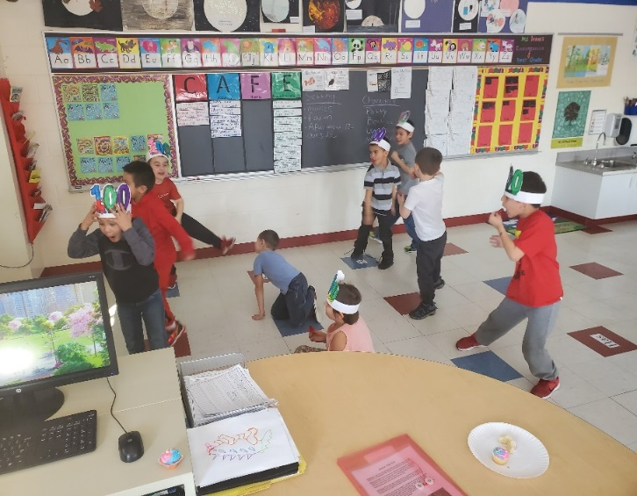 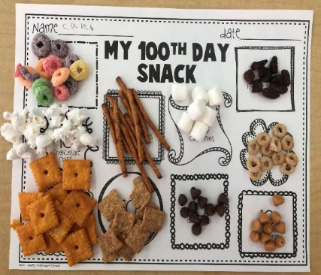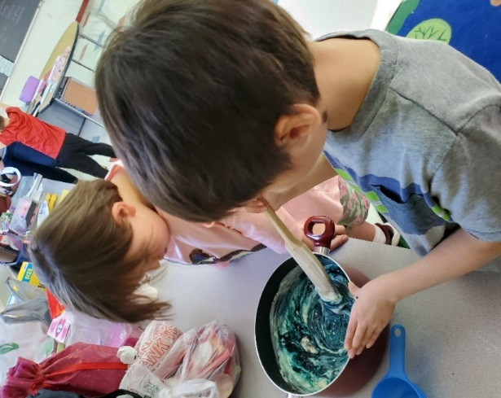

4,5,6 Grade   Mr. Brooks/Miss Kat

Boozhoo!  February has been a productive yet enjoyable month for our students!  We have celebrated 100 days of school and Valentine’s Day!  Hard to believe we’ve already reached the 100 day mark, time is flying by!

Our Valentine’s Day Celebration went great!  The kids were very creative in designing and making their Valentine’s boxes and cards.  All the students at the school really had an enjoyable time, especially exchanging valentines.  Afterwards are kids enjoyed a great game of Oshki ball with the 1-2 Grade Class.  Miigwech to everyone who helped make their day so special and memorable.

Our kids have also got the opportunity to learn and participate in rabbit snaring.  They each learned how to spot their tracks, and set a snare, and each one of them went out and did so!  They were fortunate and succeeded in getting two rabbits that were used at this month’s Food For Thought!  So proud of you all!

In Science, the students worked in teams to design a go cart system that could perform specific functions.  They are learning great engineering practices, this applies scientific understanding to design solution to human problems.

In History, they are learning about the Civil War and how it was fought between southern and northern states of the United States.

This past week the students got to enjoy some great traditional Ojibwe Storytelling with Gordon Jourdain.  As always, is was a great afternoon and the students were happy to see him again this year!