December 19, 2019 / Manidoo- Giizisoons – Little Spirit Moon

Volume 8 Issue 8
Oshki Ogimaag 73 Upper Rd, PO Box 320

Upcoming Events
OOCS students and staff will be on Winter Break December 20- January 1.
Classes RESUME on January 2.

All meals come with bread & milk
OOCS menu can be found at oshkiogimaag.org

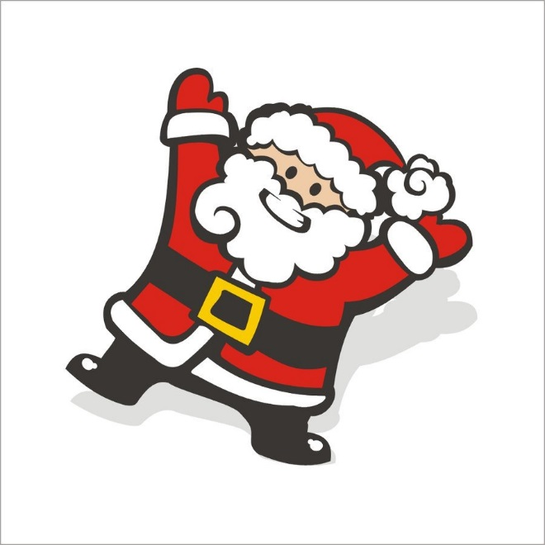

www.oshkiogimaag.org (218) 475-2112

We made it to Winter Break already!
Tonight at 5:30 students should report to OOCS ready for the Holiday program
The Annual Holiday program will begin at 6:00 in gym-
Following the program a special guy in a red suit may make an appearance and give out gifts to community kids!

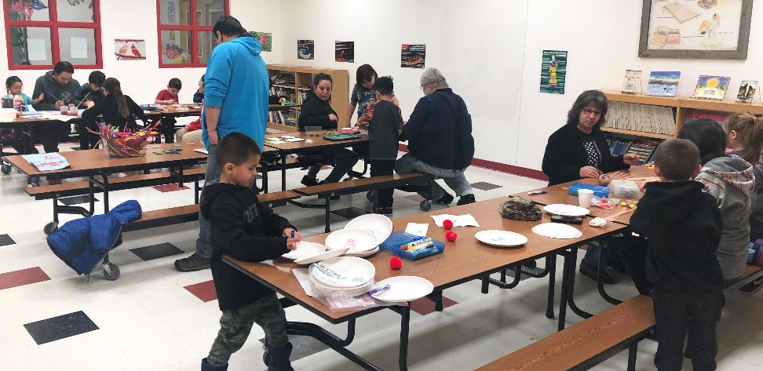
We hope you and your children have a relaxing yet fun Holiday break together! Read some books together, sing some songs, play and have FUN! If it warms up outside go and make a snowman or go sliding! Stay safe and make happy memories.

Starting in December, one student in the school will receive a HO-WAH! certificate for excellence in Ojibwe that week. Our first HO-WAH! certificate was awarded to Ira Battees. Good job Ira!
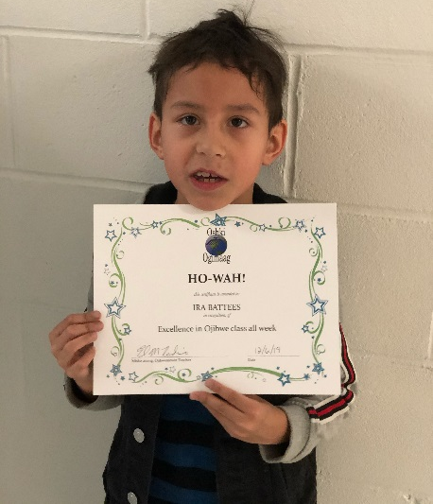

Kindergarten NEWS
Congratulations to Nathaniel for receiving the HO-WAH award in Ojibwe. In science the students finished up their pond habitat unit. Our end of unit project was to make a diorama of a pond habitat. Each group was given the same materials and they did a great job working together to create their own ponds. The students were invited to the Heritage Center to sing their Christmas songs during their annual holiday event and they sang great! They are excited to sing in front of the whole community on Thursday night. All students should meet at Oshki dressed and ready to perform at 5:30pm, the program starts at 6pm! Over the winter break, please help your child practice letter names and sounds, reading red words (I, A, the, see, was, is, of, for, and, has.) Have a great Christmas Vacation!

