APRIL 3, 2020 – Iskigamizige-Giizis / sap boiling moon

Volume 8 Issue 13

Oshki Ogimaag Charter School 73 Upper Road Grand Portage, MN

www.oshkiogimaag.org 218-475-2112

Boozoo Oshki families, Thank you for your patience through this challenging time. The staff here at OOCS have been doing an amazing job coming up with creative ways to teach their students from a distance. We will continue to do our best, if you have any questions or concerns or positive feedback, we would love to hear it. Stay healthy everyone. We hope we can see your smiling faces soon. Ms. Carmen

Kindergarten News: From the desk of Ms. Jeana
I hope the first week of distance learning is going okay for everyone and isn’t too stressful. Here are some helpful tips to get you through this time.
- Keep emotional health a top priority. Make your relationship and connecting with your child your top priority. Model positivity and kindness.
- You do not need to replace your child’s teacher or be an expert on every subject. Learning at home is different. Be patient, kind, and flexible with yourself and your child.
- Create a consistent learning at home routine. Routines make children feel safe and are especially important in stressful times.
- Look for learning moments that are unique to the home environment. This can include cooking, chores, games, learning something new, etc. Think about the math, literacy, and science skills involved in day-to-day tasks and involve your child.
- Provide encouragement and support. If your child is feeling overwhelmed or confused reassure them that learning takes time and mistakes are okay.
- Have your child teach you. Give your child opportunities to teach you about what they are learning. It is a great way to discover if they really understand something and gives them an opportunity to be the expert.
- Your children will miss their friends and old routines. Be patient, supportive, and loving. When possible, look for ways to spend time together and connect with others through technology or mail.
Contact information: Email: jvandyne@oshkiogimaag.com or msherer@oshkiogimaag.org OOCShelp@oshkiogimaag.org or call 475-2112 or message on classdojo
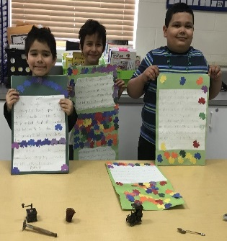
Grades 1 and 2
After writing and decorating their poems about Leprechaun's, the first and second graders were very excited to find items that the leprechauns left in their classroom! A miniature coffee grinder, a fishing basket, a rake, a shovel, a spoon and even a miniature car! The leprechauns were thrilled to hear the Dr. Seuss stories the class was reading and left a treat of Green Eggs and Ham for them....of course they were miniature in size and Ms. Clearwater had to deliver them to homes due to Distance Learning! We are all logging into www.classdojo.com to continue our studies while we are at home. Our folders of daily work are being delivered with our lunches and our work is being returned the next school day!

Boozhoo gakina awiya!

The challenge of distance learning has brought our Grades K-2 a good opportunity to bring Ojibwemowin into their homes! Students have been sent home labels and have done an excellent job labeling items around their home! We will continue this activity through next week, so if you are behind on this activity, get your students pictures uploaded through the Class Dojo site.
Grades 4-6 have been doing worksheets reviewing our verbs we've been working with all year. For example:
Ninibaa. I'm sleeping.
Ningii-nibaa. I slept.
Niwii-nibaa. I want to sleep.
Students have done very well, my only concern is that there has been some struggle with the negative forms:
Gaawiin ninibaasiin. I'm not sleeping.
Gaawiin ningii-nibaasiin. I didn't sleep.
Gaawiin niwii-nibaasiin. I don't want to sleep.
You'll see that in the last three sentences all you have to do is insert "Gaawiin" at the beginning, and "-siin" at the end of the first three sentences to negate them. For example, "I'm sleeping" is "Ninibaa" and to say "I'm not sleeping" its "Gaawiin ninibaasiin."

4-6 Class Mr. Brooks/Miss Kat
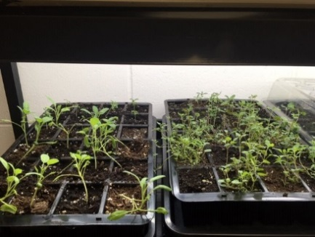
Boozhoo everyone! Well the distant learning has started, and we have been busy in the classroom getting things prepared and organized the best we can to send home to you students. I tell you, it sure is not the same without you guys, we do miss you, but we are also fortunate to have Classdojo as a means to keep up communication with you as well! Remember we are only a phone call away if needed as well.
I thought that I would take a couple pictures of the plants that you all have started and show you the progress! They are doing an awesome job, look at how much they have grown!!
This time of year is our Sugarbush time, even though we are not doing our norm this year, I’ve still been getting out there and tapping a few trees myself. Here’s a couple pics I took the other day.
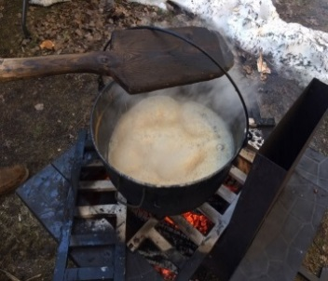
While we are all home together during this health crisis, remember our Mashkiki-medicines for our protection.
Tobacco is the first plant that the Creator gave the Anishinaabe people. The three other plants: sage, cedar and sweetgrass are also held sacred by the people. Together they are referred to as the four sacred medicines. The medicines are used in everyday life and in all our ceremonies.
Asemaa- Sacred tobacco was given to the Anishinaabe so that we can communicate with the spirit world. Tobacco is always offered before picking other medicines. When you offer tobacco to a plant and explain your reasons for being there, the plant will let all the plants in the area know your intentions and why you are picking them. Tobacco is used as an offering and a gift and is important part of our ceremonies.
Elders are telling us all to hang a tobacco tie in white on our doors during this time. We have asemaa at the school if you need and white cloth to make the tobacco ties.
Wiingashk- Sweetgrass is the sacred hair of Mother Earth. Its sweet aroma reminds our people of the gentleness, kindness and love she has for the people. When sweetgrass is used in a healing circle it has a calming effect. Use it in your smudge for purification. Mashkodewashk- Sage is used to prepare our people for ceremonies and teachings. Sage is used for releasing what is troubling the mind and removes negative energy. Smudge daily! Giizhik-Cedar is used to purify the home; it also has many medicinal uses. When mixed with sage for tea, it cleans the body of infections, cedar baths are healing, smudge with all our medicines. Stay healthy. Stay Safe. Stay Home. From the desk of Ms. Bonita

