September 3rd, 2019 – Waatebagaa-Giizis

leaves turning color moon

Volume 8 Issue 1
Oshki Ogimaag

Upcoming Events
September 13 Dental checks
September 18 School Board meeting 4:30
October 11 No school for students
October 14 School Pictures
October 14 Community FEAST presented by OOCS students and staff

LUNCH MENU September 9-20

Monday – Hotdogs, Tater tots, beans
Tuesday – Hard shell tacos, corn, cornbread
Wednesday - Chicken gravy/mashed potatoes, green beans,
Thursday – Tater tot Hotdish, salad
Friday – Fish sticks, mac & cheese, corn
Monday-Tomato soup, grilled cheese, carrots
Tuesday- Chicken Patty on bun, fries, peas
Wednesday- Hamb gravy on potatoes, green beans
Thursday- Bosco sticks, salad
Friday- Sloppy joes, veggie sticks

All meals come with bread, fruit & milk
Monthly menus are posted on our website so you can see the full month at a glance.

73 Upper Rd, PO Box 320
www.oshkiogimaag.org (218) 475-2112

Welcome to the 2019-2020 School Year. We have exciting new changes at OOCS! Mr. Erik Redix has joined our team as the Ojibwe Language Teacher, Mr. Brooks Midbrod has joined as Teacher for grades 4-6 and Mrs. Jeanne Vogel decided to not be retired and came back to prepare and serve our great meals. Watch for a biography about all of them in future newsletters.
We will continue our Wednesday’s at Wabaan this year- the difference will be that we will go after lunch each week. Starting September 11 make sure your students have the proper gear needed for hiking in the woods and learning in the outdoors. If you are unable to provide outdoor gear please contact me at the school and I will make sure your child has access to warm gear.
We will be going wild ricing in September- watch for dates and details.
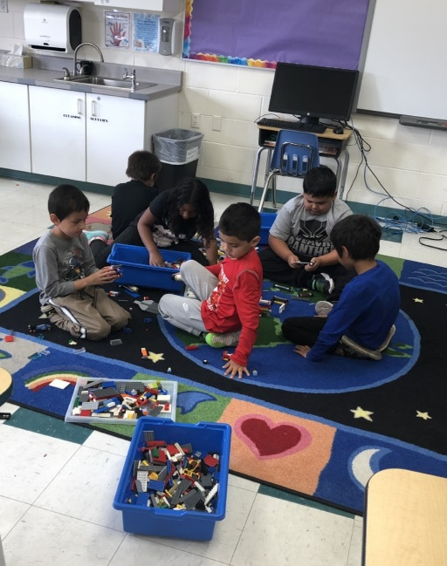
In mid-September we will be partnering with Cook County Tennis Association for part of our phy ed curriculum. This will help with balance, confidence, coordination, large motor, etc
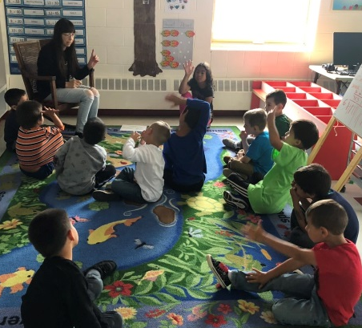

Student attendance at school is very important- Showing up for school has a huge impact on a students’ academic success! We realize some absences are unavoidable due to health problems or other circumstances. But we also know that when students miss too much school-regardless of the reason-it can cause them to fall behind academically. We don’t want your child to fall behind in school and get discouraged. Please ensure that your child attends school every day and arrives -on time. In the event your child does miss school please call 475-2112 or send a note to let us know why they were absent.

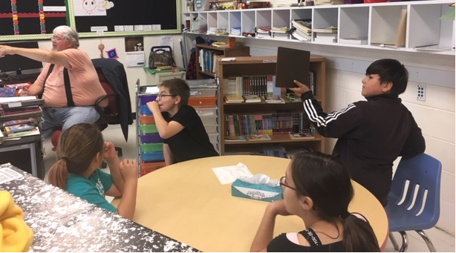

OOCS is teaming up with the Cook Co Oral Health Task Force for
a dental peak and fluoride treatment- Only students
that return their permission slip will be seen by a dental hygienist.

